INTRODUCTION

DESCRIPTION

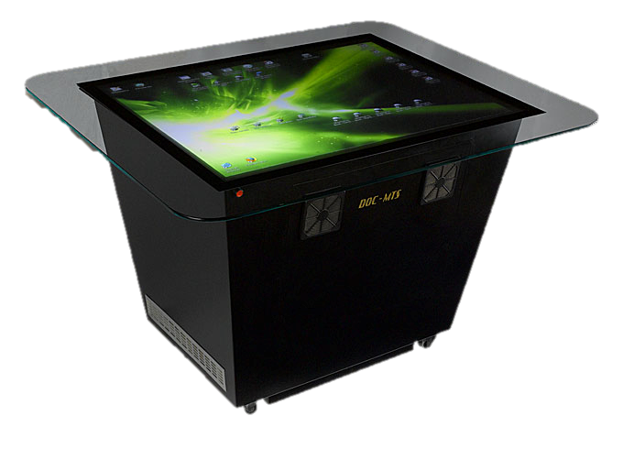Multi-touch is an enhancement to [touchscreen](http://en.wikipedia.org/wiki/Touchscreen) technology, which provides the user with the ability to apply multiple [finger gestures](http://en.wikipedia.org/wiki/Gesture_recognition) simultaneously onto the [electronic visual display](http://en.wikipedia.org/wiki/Electronic_visual_display) to send complex commands to the device.

Morphing is a useful technique for computer animation, modelling, and shape recognition, which involves establishing and computing a realistic continuous transformation which changes one object into another. Our goal is to provide the animator with an intuitive interface to specify the desired correspondences between the important features of each polyhedron and to specify the trajectories for each of these correspondences to travel during the morph. From the user’s specification, the system should generate a morph that results in a smooth and visually pleasing transition from one polyhedron to the other.

## 

PURPOSE

The purpose of this project is to allow Multitouch Scenarios for Morphing, which creates a touch enabled morphing ability that can be used in various commercial fields.

SYSTEM ANALYSIS

EXISTING SYSTEM



* In existing system, morphing based on films, a morph would be achieved by cross-fading from the motion picture of one actor or object to another. Because of the limitations of this technique the actors or objects would have to stay virtually motionless in front of a background that did not change or move in the frame between the before and after shots.
* It comprised a series of black and white close-up shots of faces of many different people that gradually faded from one to the next.
* These involved distorting one image at the same time that it faded into another through marking corresponding points and vectors on the "before" and "after" images used in the morph.

PROPOSED SYSTEM

* The proposed system uses the linear polygon morphing.
* In the proposed system we used frame to frame transition which is very effective way of morphing.

PROBLEM FORMULATION

Morphing refers to the process of transforming one shape (the source) into another (the target). Morphing is widely used in computer graphics, animation, and modelling. In planar graph morphing, we will transform a given source graph to another pre-specified target graph. A smooth transformation of one graph into another can be useful for numerous problems from graph drawing. In particular, when dealing with dynamic graphs and graphs that change through time, it is crucial to preserve the mental map of the user.

Thus, it is important to minimize the changes to the drawing and to create a smooth transition between consecutive drawings. In this paper, we consider the problem of morphing between two drawings, Ds and Dt, of the same planar graph G = (V: E). We assume that both drawings realize the same embedding of G, and have the same outer-face, and are intersection-free.

Feasibility study

**Operational Feasibility**

1. The proposed system eliminates and replaces the use of keyboard as input device with multi-touchpad’s that provides user friendly and stable input platform.

**Technical Feasibility**

1. Hardware requirements are to be purchased or designed; accuracy is dependent on the designed platform.
2. Software design does not pose any problems due to platform independent design and can be upgraded to future designs.
3. Accurate ease of access and reliability is ensured.

**Economic Feasibility**

1. The cost of hardware is quite deliberate and might require a lot of research to build the proposed hardware.
2. The Proposed system is user friendly and interactive.



Software Environment

### Java Technology

Java technology is both a programming language and a platform.

### The Java Programming Language

### The Java programming language is a high-level language that can be characterized by all of the following buzzwords:

* Simple
* Architecture neutral
* Object oriented
* Portable
* Distributed
* Secure
* High performance
* Interpreted
* Multithreaded
* Robust
* Dynamic

With most programming languages, you either compile or interpret a program so that you can run it on your computer. The Java programming language is unusual, means, a program is both compiled and interpreted. With the compiler, first you translate a program into an intermediate language called Java byte codes — the platform-independent codes interpreted by the interpreter on the Java platform.

The interpreter passes and runs each Java byte code instruction on the computer. Compilation happens just once; interpretation occurs each time the program is executed.

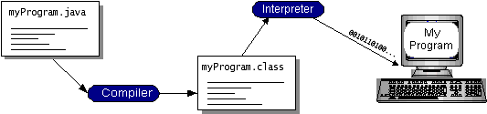The following figure illustrates how the concept works.



Java byte-codes are similar to the machine code instructions for the Java Virtual Machine (Java VM). Every Java interpreter, whether it’s a development tool or a Web browser that can run applets, is an implementation of the Java VM. Java byte-codes helps making, “write once, run anywhere” possible. You can compile your program into byte-codes on any platform that has a Java compiler. The byte-codes can then be run on any implementation of the Java VM.

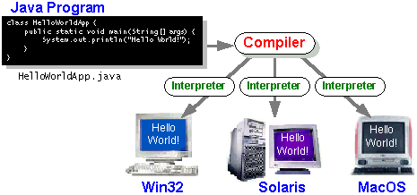

It means that as long as a computer has a Java VM, the same program written in the Java programming language can run on Windows 2000, a Solaris workstation, or on a Mac.

### The Java Platform

A platform is the hardware or software environment in which a program runs. Most platforms can be described as a combination of the operating system and hardware. The Java platform differs from most other platforms, in that, it’s a software-only platform; that runs on top of other hardware-based platforms.

The Java platform has two components:

* The Java Virtual Machine (Java VM)
* The Java Application Programming Interface (Java API)

Java Virtual Machine is the base for the Java platform and is ported onto various hardware-based platforms.

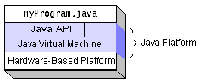The Java API is a large collection of ready-made software components that provide many useful capabilities, such as graphical user interface (GUI) widgets. The Java API is grouped into libraries of related classes and interfaces; these libraries are known as packages.

The figure besides depicts a program that’s running on the Java platform. As the figure shows, the Java API and the virtual machine insulate the program from the hardware.

Native code is a code that, after you compile it; the compiled code runs on a specific hardware platform. As a platform-independent environment, the Java platform can be a bit slower than native code. However, smart compilers, well-tuned interpreters, and just-in-time byte-code compilers, can bring performance close to that of native code without threatening portability.

SYSTEM DESIGN

DESIGN SPECIFICATION AND REQUIREMENTS

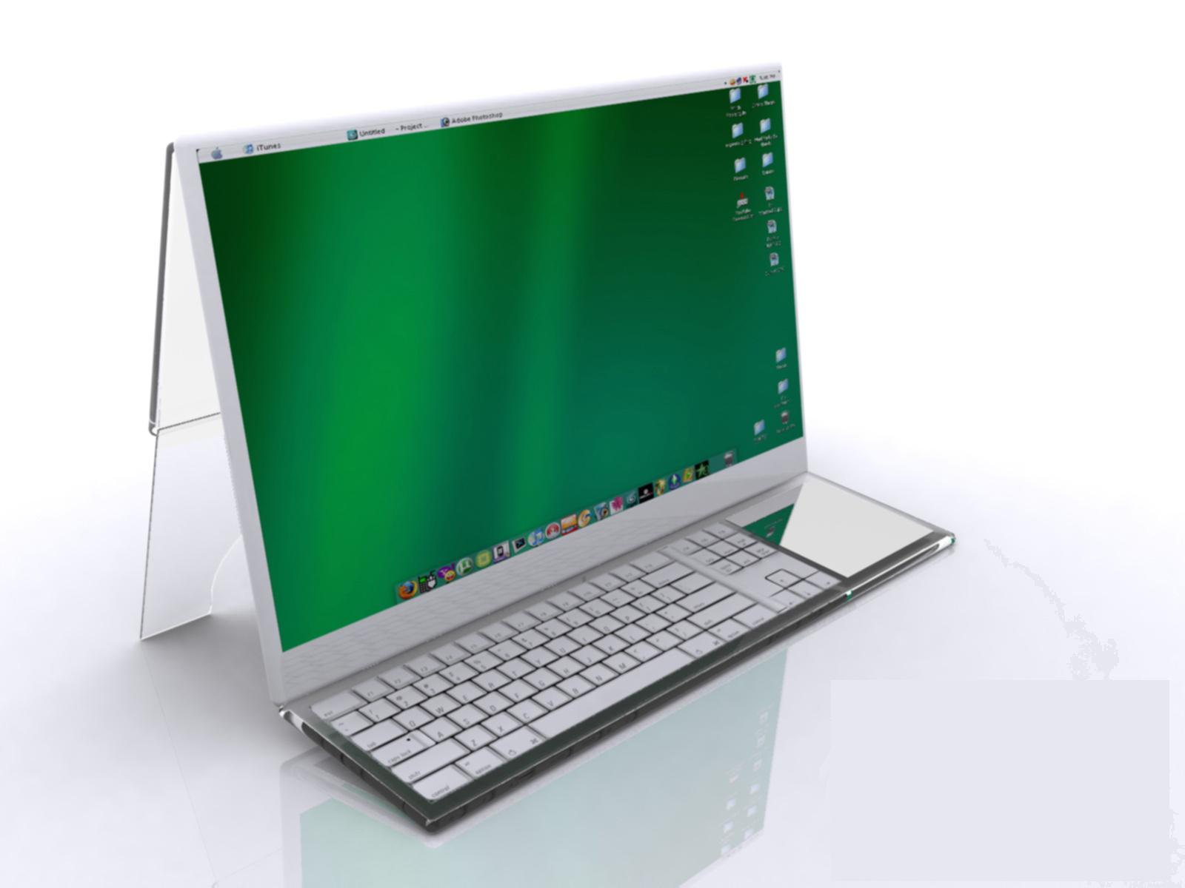HARDWARE SPECIFICATION

* **Processor** : Core 2 Duo 2.0 GHz
* **RAM** : 2 GB
* **Hard Disk** : 15 GB
* **Input device** : Multitouch Computer / Multitouch

Input Device

* **Output device** : Multitouch Computer / Monitor

SOFTWARE SPECIFICATION

* **Operating System** : Windows XP, Vista or 7
* **Software Environment** : JDK 1.5
* **External Tools** : MT Mini Package/Touchlib , TUIO

Mouse

Data Flow Diagram

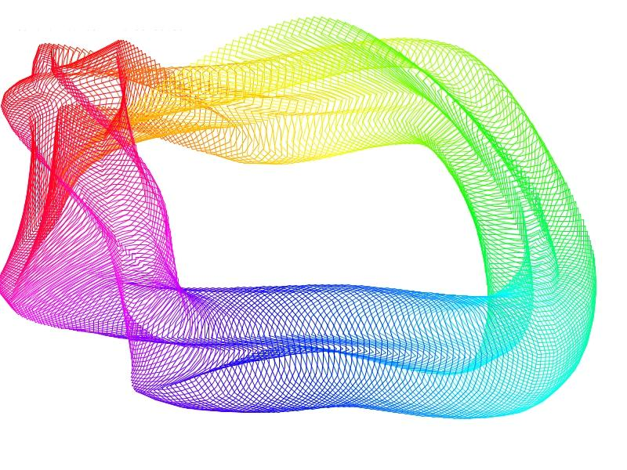

Read the time delay

Read the steps

Read the Original polygon

Read the destination polygon

Find the vertex

Find the direction

Find the interpolation points

Start morphing

Play or pause it.

Observe the change in object

Software Design

MORPHING TECHNIQUE - LINEAR INTERPOLATION

**Linear Interpolation** is a method that can be used for predicting. Very often things changes over a period of time: an object might change its position; a computer graphic image might change its shape; population might increase. **Linear interpolation** allows you to predict an unknown value (position, shape, population, etc.) if you know any two particular values and assume that the rate of change is constant.

**Linear interpolation** assumes that:

* You know two particular values.
* The process is changing at a constant rate.
* You desire to find an unknown data point.

As a warm up example, consider flying a plane from a point ten miles north of Providence at a rate of 200 miles per hours headed due north. How far from Providence will you be after one-half hour?

1. We know the constant rate of change: 200 miles per hour in northern direction.
2. We know one point along the process: initially(time=0) we are 10 miles due north of Providence.
3. We want to find another point along the process, knowing the new time is one-half hour.

If you travel at 200 mph for one-half hour, you would have travelled 100 miles. You were initially 10 miles from Providence. Your final position will be:

10 miles + 100 miles = 110 miles due north of Providence.

To solve this problem generally, we would take the distance the plane flown and add it to 10 miles to get the plane's distance from Providence. The distance that the plane flies is calculated using the distance formula, d = r * t, where ‘d’ is the distance the plane will travel, ‘r’ is the rate at which the plane flies (200 mph), and ‘t’ is the time spent flying. Thus at any time, the distance from Providence will be:

Distance from Providence = 10 + 200 * t

We can easily predict the distance north of Providence, that, the plane will be at any time.

Let us now pose a similar problem that uses **linear interpolation** for its solution. Suppose you start at a point ten miles due north of Providence, and end 250 miles due north of Providence. Your flight direction is due north. How far from Providence will you be when your flight time is 25% completed, assuming you travel at a constant rate of speed?

The total distance for the flight is 250 miles - 10 miles = 240 miles.

If your speed and direction of flight are constant, then when your flight is completed you would have completed 25% of 240 miles, or 0.25 * 240 = 60 miles

We started ten miles north of Providence, so our final distance from the city will be

10 miles + 60 miles = 70 miles

Here we knew the initial and final positions of the plane, and were able to calculate an in-between position. This process of calculating unknown values from known values when we assume a constant rate of change is called **linear interpolation.**

Notice that there was no need to know the speed at which the plane was travelling. The assumption of constant speed was sufficient.

**HOW LINEAR INTERPOLATION WORKS:**

***Keyframes***

The extent to which an image changes from one frame to the next and the methods for controlling such changes are obviously important in sustaining the illusion of motion. A common basic means for envisioning and executing a series of changing images is to use ‘keyframes’, describing the extremes of a character's motion. Deducing the other “in-between” frames, requires a little artistic decision making. In traditional animation houses, an animator draws the keyframes and assistants and “mediators” draw the in-between frames. However, even with acetate cells to layer images and reuse stationary components, this is an extremely time-consuming task that requires skills and patience. Even a five minute animation movie short, for instance, has 5 minutes x 60 seconds/minute x 24 frames/second = 7,200 frames and a feature length film has over a hundred thousand. Although keyframes and pencil tests (sequences drawn with outlines and not yet filled in with colors) provide some feedback before each frame is created in full detail, the traditional process requires very careful advance planning and last minute experimentation can be prohibitively expensive.

***In-betweening***

The computer can expedite the animation process by producing in-between frames automatically. In its simple scenario, the goal is to animate a ball thrown in the air; starting at ground level, rising into the air while moving sideways, and returning to the ground. The three keyframes needed are the ball's beginning and end positions and highest point. Now, instead of drawing the intermediate frames by hand, the artist can choose to in-between these frames automatically.

***Linear Interpolation***

The simplest kind of automatic in-betweening is linear in-betweening which is done with a mathematical process of guessing intermediate locations called linear interpolation. To interpolate means, to calculate a new value in between two known values. Linear interpolation creates new values at equal distances along a line between two known values. In animating, an object moving between two points in space, linear in-betweening creates new frames at equal intervals along a straight line between two of the keyframes, the number of intervals (and thus number of frames) is determined by the user. If two of the keyframes are one second apart, for example, an artist has specified that the animation should run at 10frames/sec, and then the time between the frames is represented by 10 frames shown at ten equal intervals.

***Key Frame Animation***

Key frames mark important visual transitions (extremes of action).

In-betweening is creation of intermediate frames between the key frames which can be calculated by a Computer.

***Temporal Sampling***

A digitized image is composed of discrete samples of a continuous image, arranged to create the illusion of a continuous picture.

Similarly, film recording takes samples of an image at fixed time intervals--i.e., temporal samples. When these are arranged and played at a certain rate (24 frames/sec for film, 30 frames/sec for video, 60 to 70 for some fast-moving computer graphics applications), an illusion of continuous motion is created.

In-betweening is letting the computer produce additional temporal samples (frames) between predefined key frames in an animation.

**Problem**: Hard to create truly life-like animation unless keyframes are designed for almost every other frame, True in both computer and traditional animation.

Computer in-betweening is often used as aid for storyboarding, testing sequences (as in Jurassic Park).

***Geometric Transformation and Animation***

*An important distinction:*

* Geometric transformations do not create motion; they cause instantaneous changes.
* Intermediate frames necessary to create illusion of motion (animation) are created by calculating additional transformations (in-betweening).

*The Math behind In-betweening:*

* New way of thinking about linear paths that will enable us to calculate the in-between frames. Let's begin with lines:
* Given a line segment from v1 to v2, how to express midpoint? Use equal combinations of both point positions
  + x = 1/2 (x1 + x2) = (1/2) x1 + (1/2) x2
  + y = 1/2 (y1 + y2) = (1/2) y1 + (1/2) y2
* Three-fourths of the way :- Use a combination of three quarters of the final destination and one quarter of the starting point,
  + x = (1/4) x1 + (3/4) x2
  + y = (1/4) y1 + (3/4) y2
* Can think of this as weighted averages of point positions
* So, how is this related to in-betweening?
  + By letting our position on this very practically defined line, depend on another variable such as elapsed time (represented by the letter ‘t’ but note that ’ t’ does not necessarily have to be time)
* Conveniently, we have defined our trip to begin at t = 0 and end at t = 1.
* So, for a parameter t 
  + x = (1 - t) x1 + tx2
  + y = (1 - t) y1 + ty2
* Because the line definition now depends on a third parameter (not x or y, but t) it is called a parametric equation.

MULTI-TOUCH TECHNIQUES

***Object Tracking***

The task of tracking consists of reliably being able to re-identify a given object, for a series of video frames contain­ing that object (estimating the states of physical objects in time from a series of unreliable observations). In general, this is a very difficult problem, since, the object needs to be first detected (quite often in clutter, with illusions, or under varying lighting conditions) in all the frames and then the data must be associated somehow between frames in order to identify a recognized object.

In most systems, a robust background-subtraction algorithm needs to first pre-process each frame. This assures that, static or background objects in the images are taken out of consideration. Since illumination changes frequent videos, adaptive models, such as Gaussian mixture models, of background have been developed to intelligently adapt to non-uniform, dynamic backgrounds.

Once the background has been subtracted out, all that remains are the foreground objects. These objects are often identified with their centroids, and it is these points that are tracked from frame to frame. Given an extracted centroid, the tracking al­gorithm predicts where that point should be located in the next frame.

***Tracking for Multi-Touch***

Tracking is very important to multi-touch technology. It is what that enables multiple fingers to perform various actions without interrupting each other. We are also able to identify gestures because the trajectory of each finger can be traced over time which is impossible without tracking.

***Gesture Widgets***

Multi-touch based NUI (Natural User Interface) setups provide a strong motivation and platform for a gestural interface as it is object based (as opposed to WIMP) and hence removes the abstractness between the real world and the application. The goal of the in­terface should be to realize a direct manipulation, higher immersion interface but with tolerance to the lower accuracy implied with such an interface. The popular gestures for scaling, rotating and translating images with two fingers, commonly referred as manipulation gestures, are good examples of natural gestures.



New types of gesture-widgets are required to be built to fully implement the concept of direct manipulation with the objects (everything is an object in NUI with which the user can interact) and an evocative and contextual environment and not just trying to emulate mouse-clicks with a gesture. Gesture widgets should be de­signed with creative thinking, proper user feedback, keeping in mind the context of the applica­tion and the underlying environment. These gesture widgets can then be extended by the application developer to design complex applications. They should also sup­port customizable user defined gestures.

***Gesture Recognition***

The primary goal of gesture recognition research is, to create a system which can identify specific human gestures and use them to convey information or for device control. In order to ensure accurate gesture recognition and an intuitive interface, a number of constraints are applied to the model. The multi-touch setup should provide the capability for more than one user to interact with it working on inde­pendent (but maybe collaborative) applications and multiple such setups, working in tandem.

Gestures are defined by the starting point within the boundary of one context, end point and the dynamic motion between the start and end points. With multi-touch input it should also be able to recognize meaning of combination of gestures separated in space or time. The gesture recognition procedure can be categorized in three sequential processes:



* Detection of Intention: Gestures should only be interpreted when they are made within the application window. With the implementation of support for multi-touch interface in X Input Extension Protocol and the upcoming X2, it will be the job of the X server, to relay the touch event sequence to the correct application.
* Gesture Segmentation: The same set of gestures in the same application can map to several meanings depending on the context of the touch events. Thus the touch events should be again patterned into parts depending on the ob­ject of intention. These patterned data will be sent to the gesture recognition module.
* • Gesture Classification: The gesture recognition module will work upon the patterned data to map it to the correct command. There are various techniques for gesture recognition which can be used alone or in combination like Hid­den Markov Models, Artificial Neural Networks, and Finite State Machine etc.

HARDWARE Design

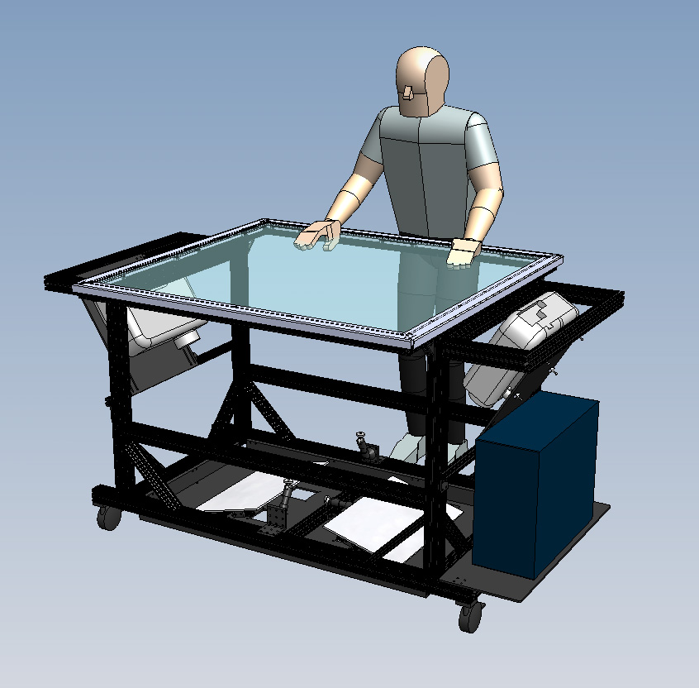Multi-touch (or multitouch) denotes a set of interaction techniques that allow computer users to control graphical applications with several fingers. Multi-touch devices consist of a touch screen (e.g., computer display, table, and wall) or touchpad, as well as software that recognize multiple simultaneous touch points, as opposed to the standard touch­.

***Optical Multi-Touch Technologies***

Optical or light sensing (camera) based solutions make up a large per­centage of multi-touch devices. The scalability, low cost and ease of setup are suggestive reasoning for the popularity of optical solutions. Stereo Vision, Overhead Cameras, Frustrated Total Internal Reflec­tion, Front and Rear Diffused Illumination, Laser Light Plane, and Diffused Sur­face Illumination are all examples of camera based multi-touch systems.

Each of these techniques consists of an optical sensor (typically a camera), infrared light source, and visual feedback in the form of projection or LCD. Prior to learn­ing about each particular technique, it is important to understand these three parts that, all optical techniques share.

***Infrared Light Sources***

Infrared (IR in short) is a portion of the light spectrum that lies just beyond what can be seen by the human eye. It is a range of wavelengths longer than visible light, but shorter than microwaves. ‘Near Infrared’ (NIR) is the lower end of the infrared light spectrum and typically considered wavelengths between 700nm and 1000nm (nanometers). Most digital camera sensors are also sensitive to at least NIR and are often fitted with a filter to remove that part of the spectrum so they only capture the visible light spectrum. By removing the infrared filter and replacing it with one that removes the visible light instead, a camera that only sees infrared light is created.

In regards to multitouch, infrared light is mainly used to distinguish between a visual image on the touch surface and the object(s)/finger(s) being tracked. Since most systems have a visual feedback system, where an image from a projector, LCD or other display is on the touch surface, it is important that the camera does not see this image when attempting to track objects overlaid on the display. In order to separate the objects being tracked from the visual display, a camera, as explained earlier, is modified to only see the infrared spectrum of light; this cuts out the visual image (visible light spectrum) from being seen by the camera and therefore, the camera is able to see only the infrared light that illuminates the object(s)/finger(s) on the touch surface.

Many brands of acrylic sheet are intentionally designed to reduce their IR trans­mission above 900nm to help control heat when used as windows. Some camera sensors have either dramatically greater or lesser sensitivity to 940nm, which also has a slightly reduced occurrence in natural sunlight.

IR LEDs are not required, but an IR light source is. In most multitouch optical techniques (especially LED-LP and FTIR), IR LEDs are used because they are efficient and effective at providing infrared light. On the other hand, Diffused Illumination (DI) does not require IR LEDs, but rather some kind of infrared light source like an infrared illuminator (which may have LEDs inside). Laser light plane (LLP) uses IR lasers as the IR light source.

Most of the times, LEDs can be bought in forms of “single LEDs” or “LED rib­bons”:

• Single LEDs: Single through-hole LEDs are cheaper and easy to create LED frames when making FTIR, DSI, and LED-LP MT setups. They require knowledge in soldering and a little electrical wiring when constructing. LED calculators make it easy for people to figure out how to wire the LEDs up. The most commonly through-hole IR LED used are the OSRAM SFH 485 P. If you are trying to make a LCD FTIR, you will need brighter than normal IR LEDs, so these are probably your best bet.

• LED ribbons: The easiest solution for making LED frames instead of solder­ing a ton of through-hole LEDs, LED ribbons are FFC cables with surface mount IR LEDs already soldered on them. They come with an adhesive side that can be stuck into a frame and wrapped around a piece of acrylic, with a continuous LED ribbon. All that is required is a wrap and plug the ribbon into the power adapter and done. The best quality ribbons can be found at envi­ronmentallights.com.

• LED emitters: When making Rear DI or Front DI setups, pre-built IR emit­ters are much easier than soldering a ton of single through-hole LEDs to­gether. For most Rear DI setups, 4 of these are usually needed to completely cover the insides of the box. By buying the grouped LEDs, you will have to eliminate “hot spot” IR blobs caused by the emitters by bouncing the IR light off the sides and floor of the enclosed box.

***Infrared Cameras***

Simple webcams work very well for multitouch setups, but they need to be modi­fied first. Regular webcams and cameras block out infrared light, letting only vis­ible light in. We need just the opposite. Typically, by opening the camera up, you can simply pop the filter off, but on expensive cameras this filter is usually applied directly to the lens and cannot be modified.

Most cameras will show some infrared light without modification, but much bet­ter performance can be achieved if the filter is replaced.

The performance of the multi-touch device depends on the used components. Therefore it is important to carefully select the hardware components.

***Frustrated Total Internal Reflection (FTIR)***

Frustrated Total Internal Reflection describes a condition present in certain materials when, light enters one material from another material with a higher refractive index, at an angle of incidence greater than a spe­cific angle. The specific angle at which this occurs depends on the refractive indexes of both materials, and is known as the critical angle.

When this happens, no refraction occurs in the material, and the light beam is totally reflected, flooding the inside of a piece of acrylic with infrared light by trapping the light rays within the acrylic us­ing the principle of Total Internal Reflection. When the user comes into contact with the surface, the light rays are said to be frustrated, since they can now pass through into the contact material (usually skin), and the reflection is no longer total at that point.

This frustrated light is scattered downwards towards an infrared webcam, capable of picking these ‘blobs’ up, and relaying them to tracking software.

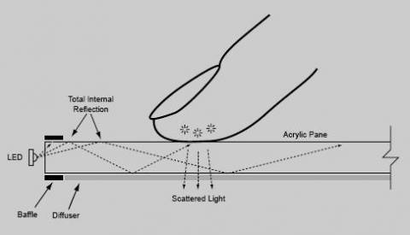

**FTIR Layers**

* **Acrylic:** it is necessary to use acrylic for the screen. The minimum thickness is 6 mm, however large screens should use 1 cm to prevent the screen from bending. Before a sheet of acrylic can be used for a multi-touch screen, it needs to be pre­pared because acrylic often gets cut up roughly; it is required to polish the sides of the sheet. This is done to improve the illumination from the sides. To polish the sheet, it is recommended to use different kinds of sandpaper.
* **Baffle:** The baffle is required to hide the light that is leaking from the sides of the LEDs. This can be a border of any material (wood/metal).
* **Diffuser:** Without a diffuser the camera will not only see the touches, but also all objects behind the surface. By using a diffuser, only bright objects are visible to the infrared camera.
* **Compliant layer**: With a basic FTIR setup, the performance mainly depends on how greasy the fingertips of the user are. Wet fingers are able to make better contact with the surface. Dry fingers and objects won’t be able to frustrate the TIR. To overcome this problem it is recommended to add a ‘compliant layer’ on top of the surface. The most selected compliant layer is, RTV Silicone Sealant coated Drafting Vellum.

CODING

software implementation

MORPHING MODULE

The polygon module does all the transformation of the polygon, of any shape to any size using the liner interpolation method. There are no limits for the number of points. The polygon can consist of any number of points. The various class file which helps us to achieve the polygon morphing is mentioned below

***Interface.java***

Handling of events takes place in this class file. This class file gives the link between the application layer and execution class. The important function of this class is to produce the values required for further execution. Ex: This helps to get the values of the co-ordinates where the mouse is clicked using the mouse handle click Function. Below mentioned are the various action listeners used in polygon morphing

* Interface ()
* delay ()
* draw ()
* drawSliderValues ()
* btnMOHnd ()
* handleMouseOver ()
* btnClkHnd ()
* normBtnHnd ()
* decSlider ()
* incSlider ()
* sliderHnd ()
* handleMouseClick ()
* setNorm ()

***Polyset.java***

This class file reads the vertex number of the polygon and the co-ordinate values. From the application layer, which is then given as parameters for further operations? The various methods probable in this class file is mentioned as follows

* PolySet ()
* GetNo ()
* Reset ()
* GetVertexno ()
* Settime ()
* Settime ()
* Gettime ()
* IsReady ()
* Init ()
* Setup ()
* Morph ()
* Get ()

***Functionhandler.java***

The vertex and the co-ordinate values got from the polyset. java, is fed as the parameter to Functionhandler.java file, this then, sets the action for the polygon. The various methods probable in this class file is mentioned as follows

* FunctionHandler ()
* handleMouseClick ()
* handleRightClick ()
* setup ()
* start ()
* pause ()
* restart ()
* report ()
* ClearScreen ()
* Draw ()
* delay ()
* polyReady ()

**Morph.java**

import java.awt.*;

import java.awt.event.*;

import java.applet.*;

import java.io.*;

import java.lan.*;

import java.util.*;

class Morph extends Frame implements MouseListener, MouseMotionListener

{

Interface inf = new Interface();

int mouseX, mouseY;

boolean initialised = false;

public void init()

{

addMouseListener(this);

addMouseMotionListener(this);

inf.draw(this.getGraphics());

}

// Handle mouse clicked.

public void mouseClicked(MouseEvent me)

{

inf.handleMouseClick(me,this.getGraphics());

}

// Handle mouse entered.

public void mouseEntered(MouseEvent me)

{

inf.draw(this.getGraphics());

}

// Handle mouse exited.

public void mouseExited(MouseEvent me)

{

}

boolean mouseRel = true;

// Handle button pressed.

public void mousePressed(MouseEvent me)

{

}

// Handle button released.

public void mouseReleased(MouseEvent me)

{

// save coordinates

mouseX = me.getX();

mouseY = me.getY();

mouseRel = true;

}

// Handle mouse dragged.

public void mouseDragged(MouseEvent me)

{

// save coordinates

mouseX = me.getX();

mouseY = me.getY();

}

// Handle mouse moved.

public void mouseMoved(MouseEvent me)

{

inf.handleMouseOver(me,this.getGraphics());

}

public void delay(long ms)

{

try

{

Thread.sleep(ms);

}

catch(InterruptedException e) { }

}

public void initialise(Graphics g)

{

inf.draw(g);

}

public static Morph morph;

public void setNorm()

{

inf.setNorm(getGraphics());

}

public void paint(Graphics g)

{

if(initialised == false)

{

initialise(g);

initialised=true;

}

inf.draw(g);

}

public Morph()

{

morph = this;

this.addMouseListener(this);

this.addMouseMotionListener(this);

}

public static void main(String args[])

{

Morph mainFrame = new Morph();

mainFrame.setTitle("Multitouch Polygon Morphing");

WindowListener l = new WindowAdapter()

{

public void windowClosing(WindowEvent e) {System.exit(0);}

};

mainFrame.addWindowListener(l);

mainFrame.setBackground(Color.black);

mainFrame.setSize(1440,870);

mainFrame.setVisible(true);

mainFrame.delay(300);

mainFrame.inf.draw(mainFrame.getGraphics());

}

}

**Button.java**

import java.awt.*;

import java.applet.*;

import java.io.*;

import java.lang.*;

import java.util.*;

public class Button

{

String strPathC,strPathH,strPathN;

int isx, isy;

int sizex, sizey;

Image picN, picH, picC;

public static final int norm = 0, hilite = 1,

clicked = 2;

public int state = 0;

public int prevState = 0;

String strHelp;

public String getHelp()

{

return strHelp;

}

public Button(String _pathC, String _pathH,

String _pathN, int _isx, int _isy,String help)

{

strPathC = _pathC;

strPathH = _pathH;

strPathN = _pathN;

isx = _isx;

isy = _isy;

picN = null;

picC = null;

picH = null;

strHelp = help;

}

public void initAll()

{

picN =Toolkit.getDefaultToolkit().createImage(strPathN);

picH = Toolkit.getDefaultToolkit().createImage(strPathH);

picC = Toolkit.getDefaultToolkit().createImage(strPathC);

}

public void drawNorm(Graphics g)

{

if(picN == null)

{

picN = Toolkit.getDefaultToolkit().createImage(strPathN);

}

g.drawImage( picN,isx,isy,null);

if(state != norm)

{

prevState = state;

}

state = norm;

}

public void drawHigh(Graphics g)

{

if(picH == null)

{

picH = Toolkit.getDefaultToolkit().createImage(strPathH);

}

g.drawImage( picH,isx,isy,null);

if(state != hilite)

{

prevState = state;

}

state = hilite;

}

public void drawClicked(Graphics g)

{

if(picC == null)

{

picC = Toolkit.getDefaultToolkit().createImage(strPathC);

}

g.drawImage( picC,isx,isy,null);

if(state != clicked)

{

prevState = state;

}

state = clicked;

}

public boolean isInRange(int x, int y)

{

if( (x >= isx && x <= isx +picN.getHeight(null)) &&

(y >= isy && y <= isy + picN.getWidth(null)) )

{

return true;

}

else

{

return false;

}

}

public int getState() { return state; }

public int getPrevState() { return prevState; }

public Point getPos() { return new Point(isx,isy);}

public void setPos(int x, int y)

{

isx = x;

isy = y;

}

public Point getWdHt()

{

return new Point(picN.getWidth(null),picN.getHeight(null));

}

}

**Interface.java**

import java.awt.*;

import java.applet.*;

import java.io.*;

import java.lang.*;

import java.util.*;

import java.awt.image.*;

import java.awt.event.*;

import java.net.*;

public class Interface

{

int begY = 25;

Image wall;

FunctionHandler fnhd = new FunctionHandler();

public int slider1Value = 50, slider2Value = 50;

Button play = new Button("imgs/PlayC.jpg","imgs/PlayH.jpg","imgs/PlayN.jpg",1019,79+begY-2,"Start Morphing");

Button pause = new Button("imgs/PauseC.jpg","imgs/PauseH.jpg","imgs/PauseN.jpg",519+400,79+begY-2,"Pause Morphing");

Button slider1Left = new Button("imgs/Slider1LeftC.jpg","imgs/Slider1LeftH.jpg","imgs/Slider1LeftN.jpg",236+400-15,103+begY-1,"Decrease Delay between steps");

Button slider1Right = new Button("imgs/Slider1RightC.jpg","imgs/Slider1RightH.jpg","imgs/Slider1RightN.jpg",311-17+400,103+begY-1,"Increase Delay between steps");

Button slider2Left = new Button("imgs/Slider2LeftC.jpg","imgs/Slider2LeftH.jpg","imgs/Slider2LeftN.jpg",378+400,103+begY-1,"Decrease number of time steps");

Button slider2Right = new Button("imgs/Slider2RightC.jpg","imgs/Slider2RightH.jpg","imgs/Slider2RightN.jpg",463-12+400,103+begY-1,"Increase number of time steps");

Button slider1 = new Button("imgs/Slider1.jpg","imgs/Slider1.jpg","imgs/Slider1.jpg",477+400,103+begY-1," ");

Button slider2 = new Button("imgs/Slider2.jpg","imgs/Slider2.jpg","imgs/Slider2.jpg",477+400,103+begY-1," ");

Button btnLogo = new Button("imgs/LogoH.jpg","imgs/LogoH.jpg","imgs/LogoN.jpg",0,begY," ");

Button fire_app = new Button("imgs/fireC.png","imgs/fireH.png","imgs/fireN.png",1115,225,"Fire Application");

Button multikey_app = new Button("imgs/multikeyC.png","imgs/multikeyH.png","imgs/multikeyN.png",1275,225,"Multikey Application");

Button photo_app = new Button("imgs/photoC.png","imgs/photoH.png","imgs/photoN.png",1115,335,"Photo Application");

Button physics_app = new Button("imgs/physicsC.png","imgs/physicsH.png","imgs/physicsN.png",1275,335,"Physics Application");

Button puzzle_app = new Button("imgs/puzzleC.png","imgs/puzzleH.png","imgs/puzzleN.png",1115,435,"Puzzle Application");

Button ripples_app = new Button("imgs/ripplesC.png","imgs/ripplesH.png","imgs/ripplesN.png",1275,435,"Ripples Application");

Button tangram_app = new Button("imgs/tangramC.png","imgs/tangramH.png","imgs/tangramN.png",1115,535,"Tangram Application");

Button wallpong_app = new Button("imgs/wallpongC.png","imgs/wallpongH.png","imgs/wallpongN.png",1275,535,"Wall Pong Application");

Button config= new Button("imgs/creditC.png","imgs/creditH.png","imgs/creditN.png",35,45,"Credits");

public Interface()

{

wall = Toolkit.getDefaultToolkit().createImage("imgs/wall.jpg");

}

public void delay(long ms)

{

try

{

Thread.sleep(ms);

}

catch(InterruptedException e) { }

}

public void draw(Graphics g)

{

int x, y;

x = 0;

y = begY;

g.drawImage(wall,x,y,null);

btnLogo.drawNorm(g);

btnLogo.drawHigh(g);

config.drawNorm(g);

fire_app.drawNorm(g);

multikey_app.drawNorm(g);

photo_app.drawNorm(g);

physics_app.drawNorm(g);

puzzle_app.drawNorm(g);

ripples_app.drawNorm(g);

tangram_app.drawNorm(g);

wallpong_app.drawNorm(g);

g.setColor(new Color(c1,c2,c3));

g.fillRect(x1,y1,x2,y2);

if(play.getState() == Button.norm ||

play.getState() == Button.hilite )

{

play.drawNorm(g);

}

else

{

play.drawClicked(g);

}

if(pause.getState() == Button.norm ||

pause.getState() == Button.hilite )

{

pause.drawNorm(g);

}

else

{

pause.drawClicked(g);

}

slider1Left.drawNorm(g);

slider1Right.drawNorm(g);

slider2Left.drawNorm(g);

slider2Right.drawNorm(g);

drawSliderValues(g);

fnhd.Draw(g);

fnhd.ClearScreen(g);

}

void drawSliderValues(Graphics g)

{

Point stPt = slider1Left.getPos();

Point pWdHt = slider1Left.getWdHt();

slider1.setPos(stPt.x + pWdHt.x - 2, stPt.y );

slider1.drawNorm(g);

float percent1 = (float)(slider1Value-sliderMin)/(float)(sliderMax-sliderMin) ;

float percent2 = (float)(slider2Value-sliderMin)/(float)(sliderMax-sliderMin) ;

float r1 = 100 + (percent1 ) * 155;

float g1 = 100 + (1.0F - percent1) * 155 ;

float r2 = 100 + percent2 * 125;

float g2 = 100 + (1.0F - percent2) * 155;

Color c1 = new Color ((int)r1,(int)g1,255);

Color c2 = new Color ((int)r2,(int)g2,255);

Point stPt2 = slider2Left.getPos();

Point pWdHt2 = slider2Left.getWdHt();

slider2.setPos(stPt2.x + pWdHt2.x - 2, stPt2.y);

slider2.drawNorm(g);

Color back = g.getColor();

Color c = new Color(255,255,255);

g.setColor(c);

g.drawString(new Integer(slider1Value).toString(),301+370,153);

g.drawString(new Integer(slider2Value).toString(),448+380,153);

}

int x1 = 0;int y1 = 845; int x2 = 1440; int y2 =900;

int c1 = 44; int c2 = 108; int c3 = 170;

int pMx = -1, pMy = -1;

String pHelp;

int helpX = 10,helpY = 860;

void btnMOHnd(Button btn, int mx,int my, Graphics g)

{

if(btn.isInRange(mx, my))

{

if(btn.getState() != Button.clicked)

{

btn.drawHigh(g);

}

if(pMx != -1)

{

g.setColor(new Color(c1,c2,c3));

g.fillRect(x1,y1,x2,y2);

g.setColor(new Color(255,255,255));

g.drawString(pHelp,helpX,helpY);

g.setPaintMode();

pMx = -1;

pMy = -1;

}

if( mx != pMx || my != pMy )

{

g.setColor(new Color(255,255,255));

if(pHelp != null)

{

if(!pHelp.equals(btn.getHelp()) && pMx != -1)

{

g.setColor(new Color(c1,c2,c3));

g.fillRect(x1,y1,x2,y2);

g.drawString(pHelp,helpX,helpY);

}

}

g.setPaintMode();

pHelp = btn.getHelp();

pMx = mx;

pMy = my;

}

}

else

{

if(btn.getState() == Button.hilite)

{

if(btn.getPrevState() == Button.norm)

{

btn.drawNorm(g);

}

else

{

btn.drawClicked(g);

}

}

}

}

static boolean cursorHand = false;

public void handleMouseOver(MouseEvent me,Graphics g)

{

int mx = me.getX();

int my = me.getY();

if(pMx != -1)

{

g.setColor(new Color(c1,c2,c3));

g.fillRect(x1,y1,x2,y2);

g.setColor(new Color(255,255,255));

g.drawString(pHelp,helpX,helpY);

g.setPaintMode();

pMx = -1;

pMy = -1;

}

if(play.getState() != Button.clicked)

{

if(fnhd.polyReady())

{

btnMOHnd(play,mx,my,g);

}

if(!cursorHand)

{

Cursor hand = new Cursor(Cursor.HAND_CURSOR);

Morph.morph.setCursor(hand);

cursorHand = true;

}

}

else

{

play.drawClicked(g);

if(cursorHand)

{

Cursor def = new Cursor(Cursor.DEFAULT_CURSOR);

Morph.morph.setCursor(def);

cursorHand = false;

}

}

if(pause.getState() != Button.clicked)

{

if(fnhd.polyReady())

{

btnMOHnd(pause,mx,my,g);

}

if(!cursorHand)

{

Cursor hand = new Cursor(Cursor.HAND_CURSOR);

Morph.morph.setCursor(hand);

cursorHand = true;

}

}

else

{

pause.drawClicked(g);

if(cursorHand)

{

Cursor def = new Cursor(Cursor.DEFAULT_CURSOR);

Morph.morph.setCursor(def);

cursorHand = false;

}

}

btnMOHnd(config,mx,my,g);

btnMOHnd(fire_app,mx,my,g);

btnMOHnd(multikey_app,mx,my,g);

btnMOHnd(photo_app,mx,my,g);

btnMOHnd(physics_app,mx,my,g);

btnMOHnd(puzzle_app,mx,my,g);

btnMOHnd(ripples_app,mx,my,g);

btnMOHnd(tangram_app,mx,my,g);

btnMOHnd(wallpong_app,mx,my,g);

btnMOHnd(slider1Left,mx,my,g);

btnMOHnd(slider1Right,mx,my,g);

if(fnhd.report() == 0)

{

btnMOHnd(slider2Left,mx,my,g);

btnMOHnd(slider2Right,mx,my,g);

}

if(play.getState() == Button.clicked && fnhd.report() == 0)

{

play.drawNorm(g);

}

}

void normBtnHnd(Button btn, int mx, int my, Graphics g,String sa)

{

if(btn.isInRange(mx, my))

{

Runtime r=Runtime.getRuntime();

Process p=null;

try

{

String s="mtmp/" + sa;

p=r.exec(s);

}

catch(Exception e)

{

System.out.println("error==="+e.getMessage());

e.printStackTrace();

}

}

}

void btnClkHnd(Button btn, int mx, int my, Graphics g, Button release)

{

if(btn.isInRange(mx, my))

{

btn.drawClicked(g);

if(release != null)

{

if(release.getState() == Button.clicked)

{

release.drawNorm(g);

}

}

}

}

int sliderMax = 99, sliderMin = 1;

void decSlider(int sliderNo)

{

if(sliderNo == 1)

{

if(slider1Value > sliderMin)

slider1Value --;

}

else

{

if(slider2Value > sliderMin)

slider2Value --;

}

}

void incSlider(int sliderNo)

{

if(sliderNo == 1)

{

if(slider1Value < sliderMax)

slider1Value ++;

}

else

{

if(slider2Value < sliderMax)

slider2Value ++;

}

}

void sliderHnd(Button slider, int mx, int my, Graphics g,

int SliderNo, int leftRight)

{

if(slider.isInRange(mx, my))

{

if(leftRight == 0)

{

decSlider(SliderNo);

drawSliderValues(g);

}

else

{

incSlider(SliderNo);

drawSliderValues(g);

}

}

}

public void handleMouseClick(MouseEvent me, Graphics g)

{

int mx = me.getX();

int my = me.getY();

if(fnhd.polyReady())

{

btnClkHnd(play,mx,my,g,pause);

btnClkHnd(pause,mx,my,g,play);

}

if(me.getModifiers() == me.BUTTON1_MASK)

{

fnhd.handleMouseClick(mx,my,g);

}

else if(me.getModifiers() == me.BUTTON3_MASK)

{

fnhd.handleRightClick(g);

}

normBtnHnd(config,mx,my,g,"Demos/Flash Demos/fire.exe");

normBtnHnd(fire_app,mx,my,g,"Demos/Flash Demos/fire.exe");

normBtnHnd(multikey_app,mx,my,g,"Demos/Flash Demos/MultiKey.exe");

normBtnHnd(photo_app,mx,my,g,"Demos/Flash Demos/Photo.exe");

normBtnHnd(physics_app,mx,my,g,"Demos/Flash Demos/Physics.exe");

normBtnHnd(puzzle_app,mx,my,g,"Demos/Flash Demos/Puzzle.exe");

normBtnHnd(ripples_app,mx,my,g,"Demos/Flash Demos/Ripples.exe");

normBtnHnd(tangram_app,mx,my,g,"Demos/Flash Demos/Tangram.exe");

normBtnHnd(wallpong_app,mx,my,g,"Demos/Flash Demos/Wall Pong.exe");

if(play.getState() == Button.clicked)

{

if(fnhd.report() == 0)

{

fnhd.setup(slider1Value,slider2Value,g);

fnhd.start();

play.drawClicked(g);

}

else if(fnhd.report() == 1)

{

fnhd.restart();

play.drawClicked(g);

pause.drawNorm(g);

}

}

if(pause.getState() == Button.clicked)

{

if(pause.isInRange(mx,my))

{

if(fnhd.report() == 2)

{

fnhd.pause();

play.drawNorm(g);

pause.drawClicked(g);

}

else if(fnhd.report() == 1)

{

fnhd.restart();

play.drawClicked(g);

pause.drawNorm(g);

}

else

{

pause.drawNorm(g);

}

}

}

if(fnhd.report() == 0)

{

sliderHnd(slider1Left,mx,my,g,1,0);

sliderHnd(slider1Right,mx,my,g,1,1);

sliderHnd(slider2Left,mx,my,g,2,0);

sliderHnd(slider2Right,mx,my,g,2,1);

}

}

public void setNorm(Graphics g)

{

play.drawNorm(g);

pause.drawNorm(g);

}

}

**FunctionHandler.java**

import java.awt.*;

import java.applet.*;

import java.io.*;

import java.lang.*;

import java.util.*;

import java.awt.image.*;

import java.awt.event.*;

public class FunctionHandler

{

PolySet P = new PolySet();

boolean active = false;

int morphing = 0;

int n;

int [] x = new int [100];

int [] y = new int [100];

int minx = 18;

int miny = 210;

int maxx = 80 + 1000;

int maxy = 253 + 550;

Color srcColor = new Color(255,0,0);

Color destColor = new Color(0,0,255);

public void FunctionHandler()

{

n = 0;

}

public void handleMouseClick(int mx,int my,Graphics g)

{

if(mx > minx && mx < maxx && my > miny && my < maxy)

{

if(morphing != 2)

{

morphing = 0;

if(thread != null)

thread.stopMe();

if(P.IsReady())

{

P.Reset();

ClearScreen(g);

}

if(active == false)

{

active = true;

}

x[n] = mx;

y[n] = my;

n ++;

if(n > 1)

{

int ym = y[n-2];

int xm = x[n-2];

Color back = g.getColor();

Color drawCol;

if(P.GetNo() == 0) drawCol = srcColor;

else drawCol = destColor;

g.setColor(drawCol);

g.drawLine(mx,my,xm,ym);

g.setColor(back);

}

else

{

Color back = g.getColor();

Color drawCol;

if(P.GetNo() == 0) drawCol = srcColor;

else drawCol = destColor;

g.setColor(drawCol);

g.drawLine(mx,my,mx,my);

g.setColor(back);

}

}

}

}

public void handleRightClick(Graphics g)

{

if(active == true)

{

active = false;

Color back = g.getColor();

Color drawCol;

if(P.GetNo() == 0) drawCol = srcColor;

else drawCol = destColor;

g.setColor(drawCol);

g.drawLine(x[0],y[0],x[n-1],y[n-1]);

g.setColor(back);

P.Init(x,y,n);

n = 0;

}

}

public void Draw(Graphics g)

{

if(P.GetNo() != 0)

{

int no = P.GetVertexno(0);

int [] xx = new int [no];

int [] yy = new int [no];

P.Get(xx,yy,0);

Color back = g.getColor();

g.setColor(srcColor);

Draw(xx,yy,no,g);

g.setColor(back);

}

if(P.GetNo() == 2)

{

int no = P.GetVertexno(1);

int [] xx = new int [no];

int [] yy = new int [no];

P.Get(xx,yy,1);

Color back = g.getColor();

g.setColor(destColor);

Draw(xx,yy,no,g);

g.setColor(back);

}

if(active == true)

{

for(int i = 0;i < n-1;i ++)

{

Color back = g.getColor();

Color drawColor = (P.GetNo() == 1) ? destColor : srcColor;

g.setColor(drawColor);

g.drawLine(x[i],y[i],x[i+1],y[i+1]);

g.setColor(back);

}

}

if(morphing == 1)

{

if(thread != null)

{

thread.interDraw(g);

}

}

}

int delay,timesteps;

Graphics graphics;

public void setup(int del, int t,Graphics g)

{

delay = del;

timesteps = t;

graphics = g;

}

Thr thread;

public void start()

{

thread = new Thr();

thread.start();

}

public synchronized void pause()

{

if(morphing == 2)

{

morphing = 1;

}

}

public synchronized void restart()

{

if(morphing == 1)

{

morphing = 2;

}

}

public int report()

{

return morphing;

}

public class Thr extends Thread

{

boolean running = true;

int i = 0;

int no;

int [] x1;

int [] y1;

void stopMe()

{

running = false;

}

public synchronized void run()

{

if(P.IsReady())

{

sMorph(delay,timesteps,graphics);

}

}

public void sMorph(int del,int t,Graphics g)

{

morphing = 2;

P.Settime(t);

P.Setup();

no = P.GetVertexno(2);

x1 = new int [no];

y1 = new int [no];

for( i = 0;i <= t && running;)

{

if(morphing == 2)

{

if(!P.IsReady())

{

break;

}

Color back = g.getColor();

if(i != 1)

{

Color white = new Color(0,0,0);

g.setColor(white);

Draw(x1,y1,no,g);

g.setColor(srcColor);

P.Morph(x1,y1,0);

Draw(x1,y1,no,g);

g.setColor(destColor);

P.Morph(x1,y1,P.Gettime());

Draw(x1,y1,no,g);

}

int dColor = 255 / t;

int cRed = (t - i) * dColor;

int cBlue = i * dColor;

g.setColor(new Color(cRed,0,cBlue));

P.Morph(x1,y1,i);

Draw(x1,y1,no,g);

g.setColor(back);

delay(del);

i ++;

}

else if(morphing == 1) { delay(10);}

else if(morphing == 0) { i = t + 1;}

}

morphing = 0;

Morph.morph.setNorm();

}

public void interDraw(Graphics g)

{

int t = timesteps;

Color back = g.getColor();

int dColor = 255 / t;

int cRed = (t - i) * dColor;

int cBlue = i * dColor;

g.setColor(new Color(cRed,0,cBlue));

P.Morph(x1,y1,i);

Draw(x1,y1,no,g);

g.setColor(back);

}

}

public void ClearScreen(Graphics g)

{

Color c = g.getColor();

Color c1 = new Color(0,0,0);

g.setColor(c1);

g.fillRect(minx,miny+10,maxx-minx,maxy-miny);

g.setColor(c);

Color c2 = new Color(255,255,255);

g.setColor(c2);

g.drawRect(minx,miny+10,maxx-minx,maxy-miny);

}

public void Draw(int x[],int y[],int n,Graphics g)

{

int offx = 0,offy = 0;

for(int i = 0;i < n-1;i ++)

{

g.drawLine(offx + x[i],offy + y[i],offx + x[i+1],offy + y[i+1]);

}

g.drawLine(offx + x[0],offy + y[0],offx + x[n-1],offy + y[n-1]);

Color c2 = new Color(255,255,255);

g.setColor(c2);

g.drawRect(minx,miny+10,maxx-minx,maxy-miny);

}

public void delay(long ms)

{

try

{

Thread.sleep(ms);

}

catch(InterruptedException e) { }

}

public boolean polyReady()

{

return P.IsReady();

}

}

**PolySet.java**

import java.awt.*;

import java.applet.*;

import java.io.*;

import java.lang.*;

import java.util.*;

class PolySet

{

int [][] x = new int [2][];

int [][] y = new int [2][];

int [] mx,my;

int n1,n2;

int n,l;

int ms,ml;

int totaltime;

int Polysset = 0;

public PolySet()

{

Polysset = 0;

}

public int GetNo()

{

return Polysset;

}

public void Reset()

{

Polysset = 0;

}

public int GetVertexno(int no)

{

if(no == 0)

{

return n1;

}

else

if(no == 1)

{

return n2;

}

return n;

}

public void Settime(int t)

{

totaltime = t;

}

public int Gettime()

{

return totaltime;

}

public boolean IsReady()

{

if(Polysset == 2)

return true;

else

return false;

}

public void Init(int x1[],int y1[],int no)

{

/* Main Code */

int which = Polysset;

Polysset ++;

x[which] = new int [no];

y[which] = new int [no];

for(int i = 0;i < no;i ++)

{

x[which][i] = x1[i];

y[which][i] = y1[i];

}

if(which == 0)

{

n1 = no;

}

else

{

n2 = no;

}

/*Main Ends here*/

/* Dummy code

x[1] = new int [3];

y[1] = new int [3];

x[0] = new int [6];

y[0] = new int [6];

x[1][0] = 0;

y[1][0] = 0;

x[1][1] = 50;

y[1][1] = 100;

x[1][2] = 100;

y[1][2] = 0;

x[0][5] = 300 + 50;

y[0][5] = 100 + 0;

x[0][4] = 300 + 0;

y[0][4] = 100 + 33;

x[0][3] = 300 + 0;

y[0][3] = 100 + 66;

x[0][2] = 300 + 50;

y[0][2] = 100 + 100;

x[0][1] = 300 + 100;

y[0][1] = 100 + 66;

x[0][0] = 300 + 100;

y[0][0] = 100 + 33;

n1 = 6;

n2 = 3;

/* Dummy ends here */

}

public void Setup() // used to add the vertices

{

if(n1 < n2)

{

n = n2;

l = 1;

}

else

{

n = n1;

l = 0;

}

int nx = (l + 1)%2;

ml = 0;

ms = 0;

int xx = 0,yy = 0;

for(int i = 0;i < n1;i ++)

{

if(i == 0)

{

xx = x[0][i];

}

else

{

if(xx < x[0][i])

{

xx = x[0][i];

if(l == 0)

ml = i;

else

ms = i;

}

}

}

for(int i = 0;i < n2;i ++)

{

if(i == 0)

{

yy = x[1][i];

}

else

{

if(yy < x[1][i])

{

yy = x[1][i];

if(l == 1)

ml = i;

else

ms = i;

}

}

}

mx = new int [n];

my = new int [n];

int diff = n1 - n2;

int small = n2;

if(l == 1)

{

diff *= -1;

small = n1;

}

int i = 0;

int j = diff / small;

if(diff % small != 0)

j ++;

int c = 0;

while(i < n)

{

for(int k = 0;k <= j && (i - c) <= diff;k ++)

{

mx[i] = x[nx][c];

my[i ++] = y[nx][c];

}

c ++;

}

}

public void Morph(int x1[],int y1[],int timestep)

{

int j = ms;

int k = ml;

int [] xx1,yy1,xx2,yy2;

if(l == 1)

{

xx1 = mx;

yy1 = my;

xx2 = x[l];

yy2 = y[l];

}

else

{

xx1 = x[l];

yy1 = y[l];

xx2 = mx;

yy2 = my;

}

for(int i = 0;i < n;i ++)

{

x1[i] = (xx1[j]) * (totaltime - timestep) + (xx2[k]) * (timestep);

y1[i] = (yy1[j]) * (totaltime - timestep) + (yy2[k]) * (timestep);

x1[i] /= totaltime;

y1[i] /= totaltime;

j = (j + 1) % n;

k = (k + 1) % n;

}

}

public void Get(int xx[],int yy[],int which)

{

int nn = (which == 0)?n1 : n2;

for(int i = 0;i < nn;i ++)

{

xx[i] = x[which][i];

yy[i] = y[which][i];

}

}

}

IMPLEMENTATION

**Main Screen**

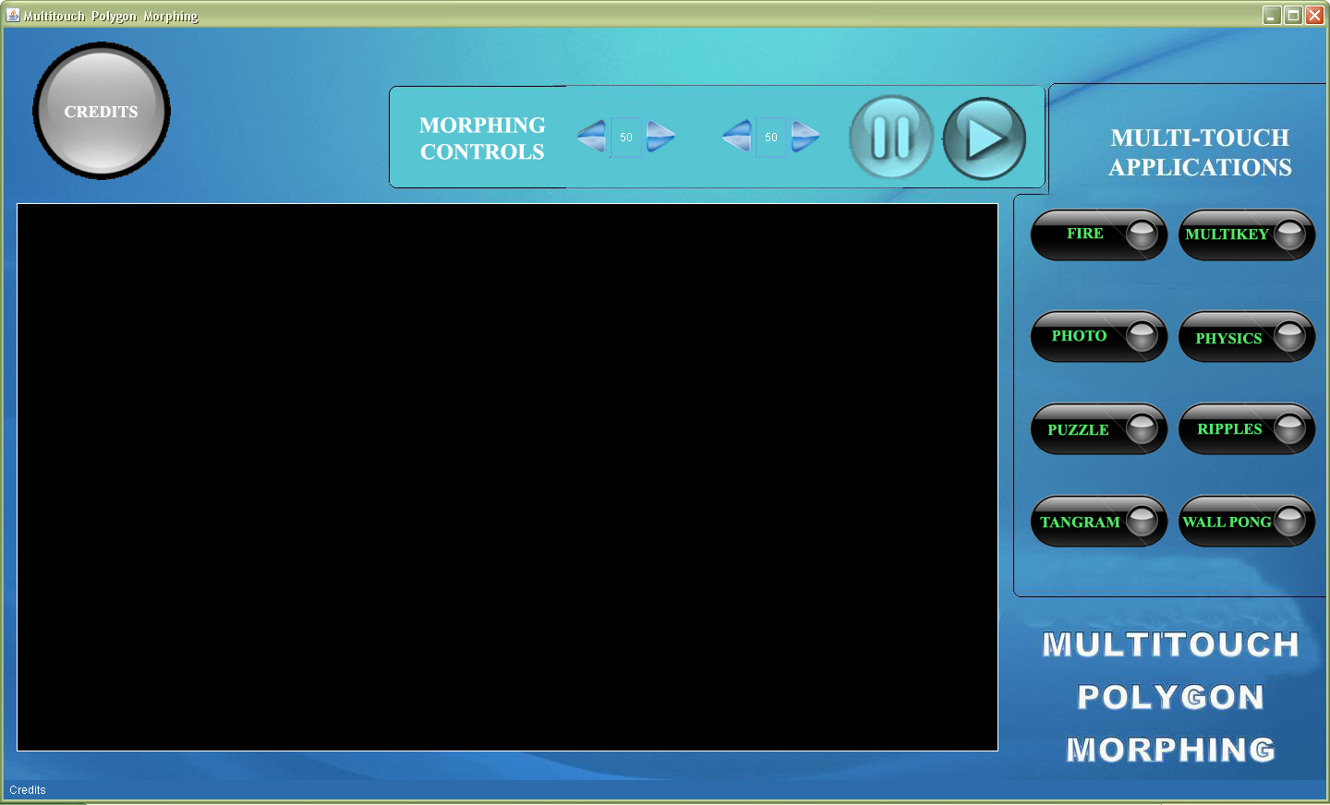

The MultiTouch Polygon Morphing is divided two basics modules: Morphing Module and the Multi-Touch Applications Module

Morphing Module

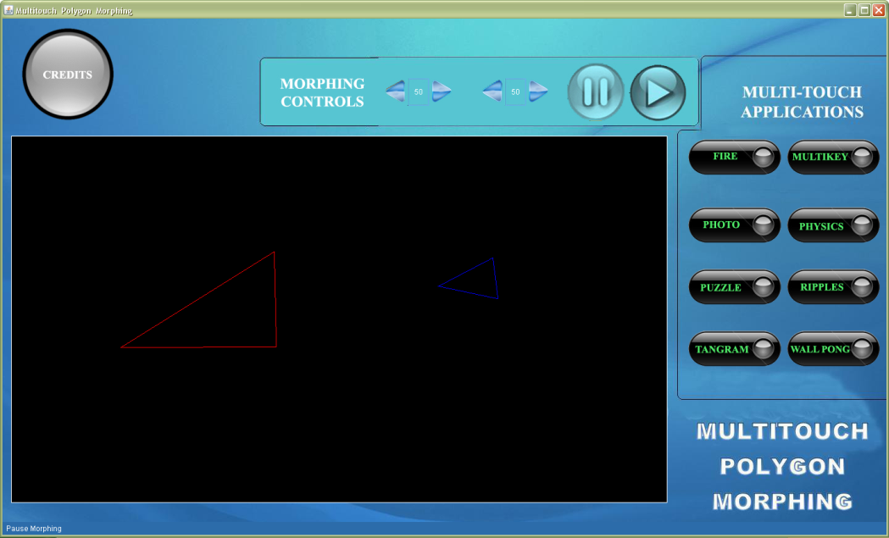

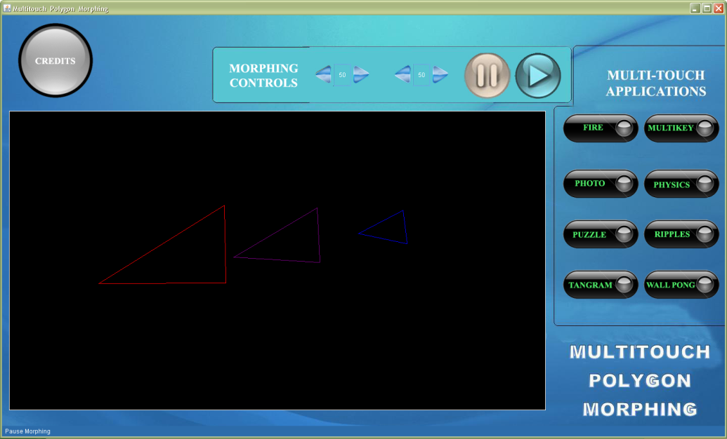

The morphing module is used to do the morphing calculations and display the morphed image which can be further implemented in different applications. When tweaked the colour code of the intermediate morphing, we achieve designs for running tunnels through caverns.

MultI-Touch Applications Module

The Multi-Touch Applications Module includes applications for the Multitouch environment such as

**Fire Application**

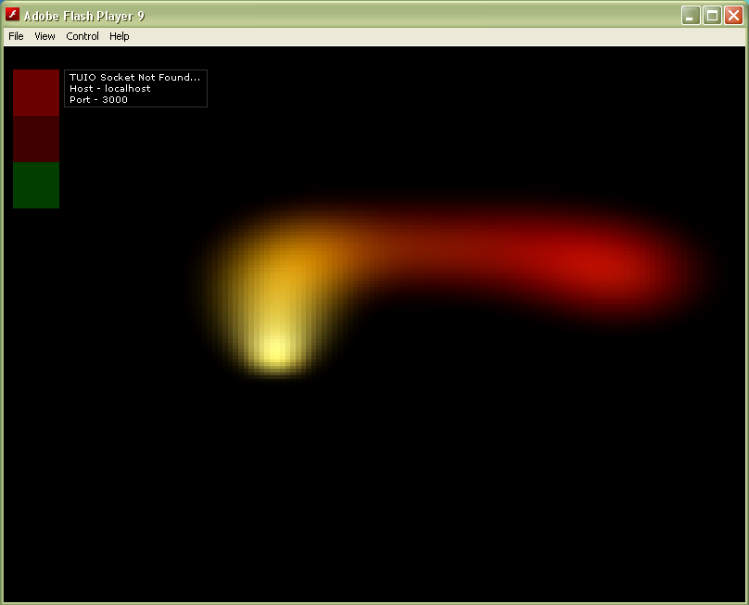

**Multikey Application**

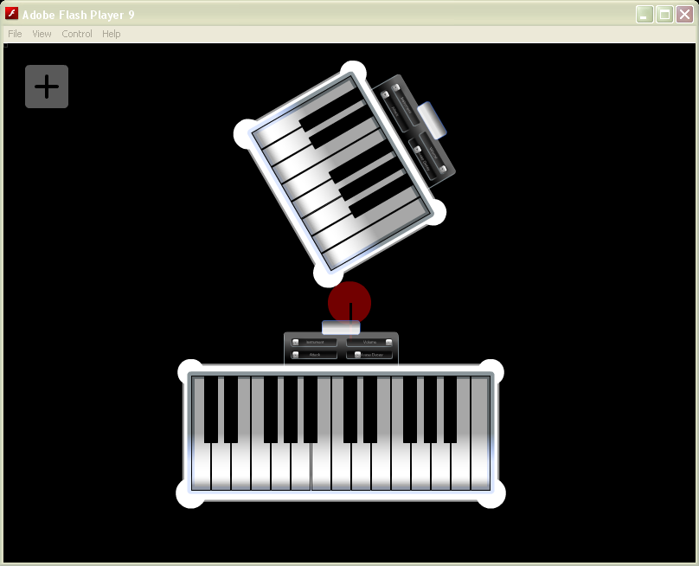

**Photo Application**

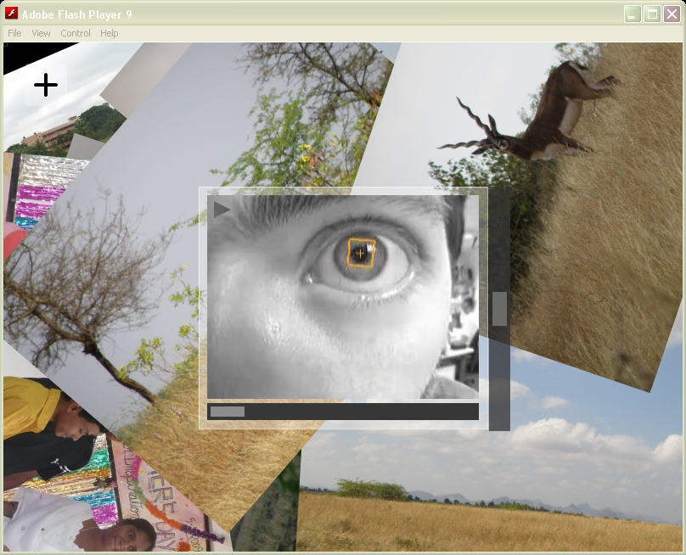

**Physics Application**

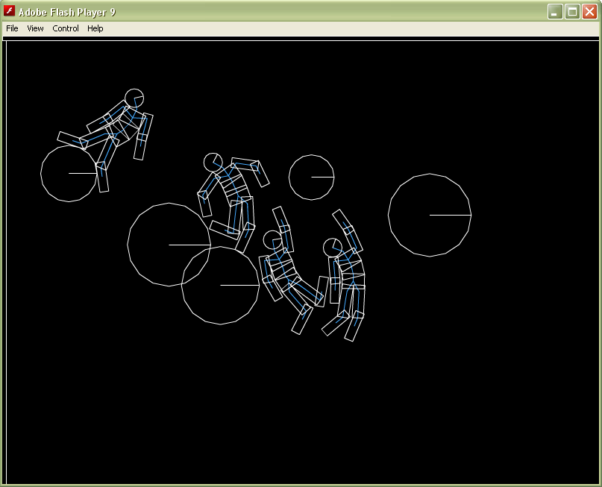

**Puzzle Application**

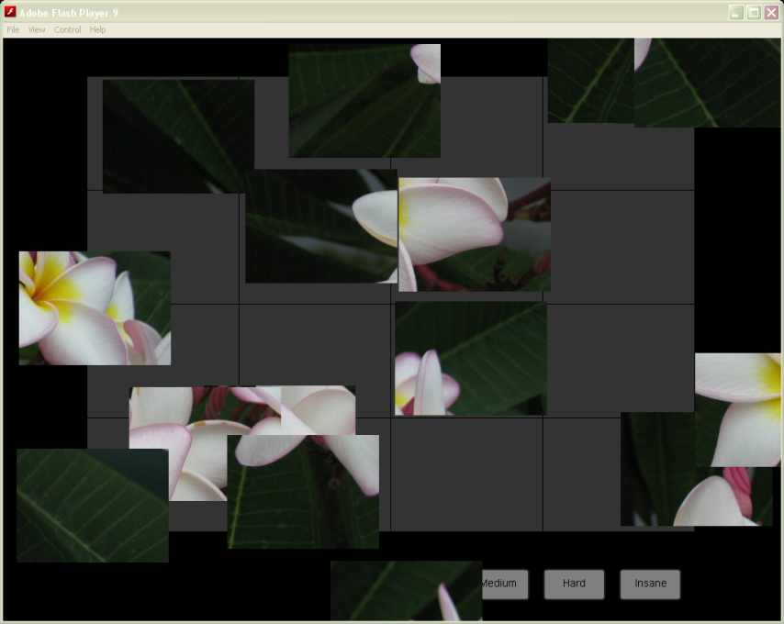

**Ripples Application**

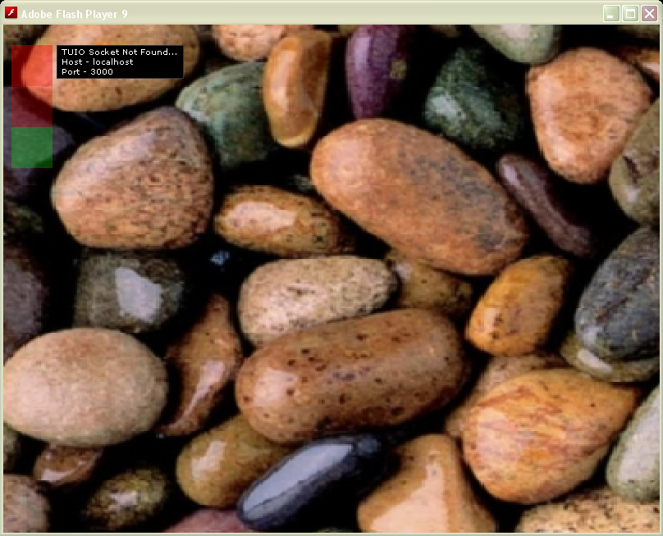

**Tangram Application**

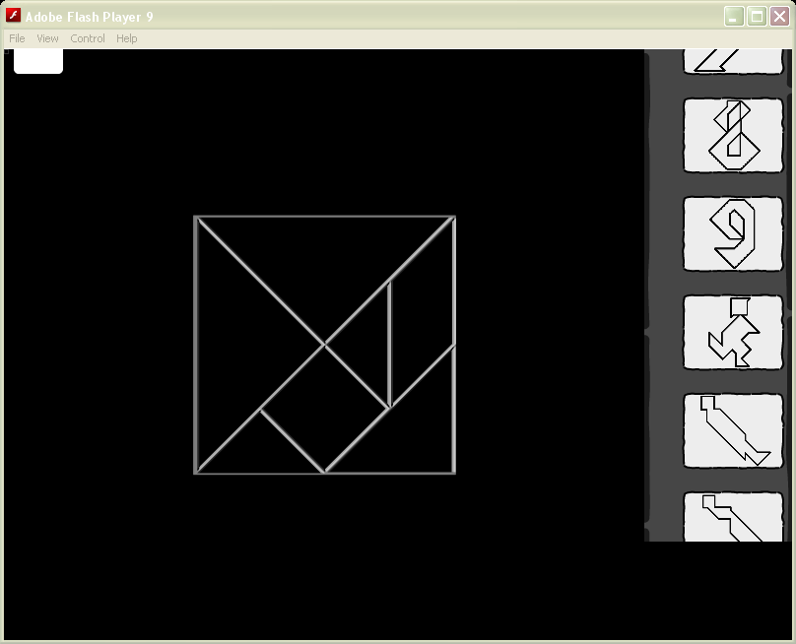

**Wall Pong Application**

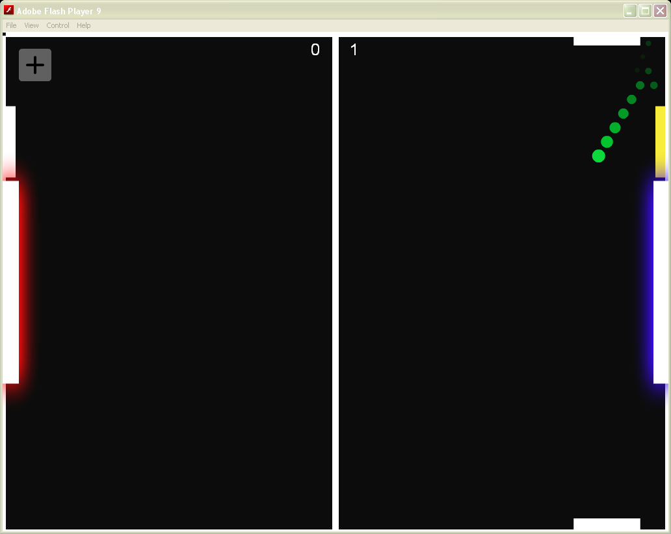

TESTING

test Plan with Test Cases

The testing process was divided into modules and then was tested individually and then we followed the following steps:

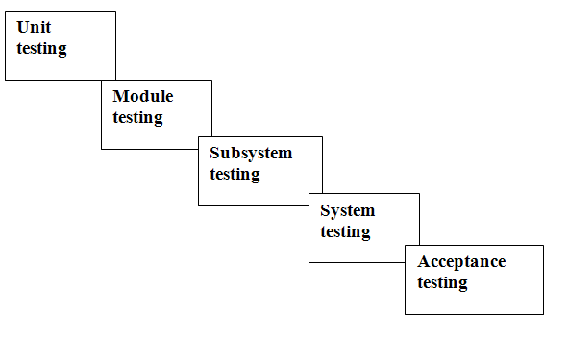

***Unit Testing***

Sample Test Cases:

|  |  |  |
| --- | --- | --- |
| **Detailed System Test Condition** | **Data Condition** | **Expected Result** |
| Check Whether Morphing is smooth and legible | Colours should be visible and precise | Morphing results are proper and can be paused and verified |
| Buttons | All buttons should be user friendly with a status display at the bottom | Buttons perform as expected and provide smooth execution for Multi-Touch |

***Module Testing***

The Multi-Touch and Morphing modules are tested in both rigorous testing conditions with expected results. They are performing on both normal computing methods and Multi – Touch Environments as designed to be executed.

However the limitations are certain, these modules are designed only for Stand alone machines and mainly used in Surface Tables.

***System testing***

Here, we had tested the entire software. The reference document for this process was the requirements document and the goal was to see that the software meets the user requirements.

The Software was tested with Multi-Touch hardware (Multi-Touch Tablet) and cross verified on all Windows Platforms.

***Acceptance testing***

Testing was performed on the realistic data of the organization to demonstrate that the software is working satisfactorily. Testing here was done to focus on the external behavior of the system; internal logic of the program is not emphasized.

***Validation and Checks***

A number of Validations and checking Constraints are used to prevent the User from entering Wrong data so that the system doesn’t show any malfunctioning nor show any unnecessary pop ups.

FUTURE DEVELOPMENT

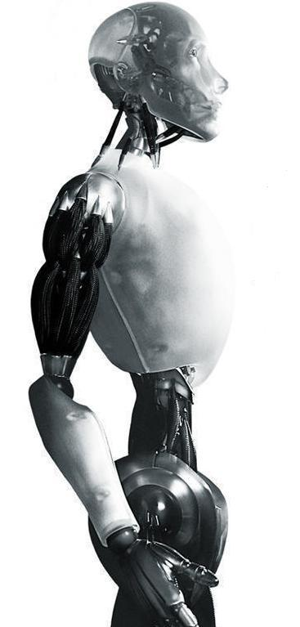

***Future of the Project***

The future use of multi-touch technology is expected to rapidly become common place in user’s environment. This Multi-Touch morphing Project is going to revolutionize the whole way of interacting with computers and morphing Capabilities.

With this creation civil engineers can detect unimaginable ways in creating structures, facial morphing can be highly progressed with user Friendly Interface.

***Applications of the Project***

Applications of Multi-touch are immeasurable; some of the applications are listed below:

1. Manipulation of digital contents (digital photos etc.)
2. Zooming
3. Drag and drop
4. MT usage in educational system (educational games)
5. Collaborative work in offices, meeting halls, exhibitions
6. Hand-eye coordination (i.e. disabilities, sport, etc.)
7. Multi-touch turntable for DJ’s (like number 1 but music not photos and more defined as an activity/application)
8. Sterile & Sterilizable computer interface/display for medical use (even in surgical bays), ability to manipulate all digital info on patient be it files or test results (MRI, x-ray, etc.)
9. Food friendly surface for use in restaurants as interactive tables/menus/Nutrition information/bill and payment system
10. Interactive gaming surface (not educational, just for fun and family) My game ideas include:
11. Multi-touch flight simulator Cockpit Controls, a panel that is easily redefined for the air plane being flown, i.e., integration into x-plane. Even a co-pilot can activate switches.
12. A really, really neat pool game (using DI, fidicuals and ‘pool cues’ on a virtual pool table) - or virtual air hockey.
13. Multi-touch poker table with virtual cards and chips. (A cupping motion of the hand over the ‘cards’ allow them to be revealed to the player - yet his hand blocks other player’s views.)
14. An extension to existing miniature games using fidicuals & DI, dynamic scenery and position tracking. So a game board that can change its appearance and be aware of the identities and locations of the playing pieces.
15. Analog and digital circuit design, verification, validation, testing....
16. Digital mixing table (Sound)
17. Clothing design; With the right interface, you could 3 dimensionally clothe and tailor virtual fabric for a ‘model’ then have the table display the patterns for cutting the fabric to create the design in real life. The design table is the pattern book for the designer. I think that would be an intuitive way to integrate high tech with an industry like fashion.
18. A multi touch digital drafting table (CAD) for architectural use… combining manipulation of “digital” drafting tools using hand / gestures and physical objects like stylus / pencil to draft / draw.
19. A star Browser. A tool that lets us explore the known universe
20. NASA space adventure simulations (for teaching purposes in schools, colleges, universities etc.)
21. Statistics, changing variables in equations using sliders to change the result
22. Editing and mixing music like a DJ (really: because it is cool)
23. Black Jack and other card games
24. Interactive maps like kiosks for travelers new to cities
25. Faster video editing, you could have a film strip that shows shot footage with each frame side by side, then you could edit or re-arrange by touch
26. Coolest web browsing you’ve ever seen
27. Real Estate Blueprint re-arranging software for like floor plans and the like
28. Paper replacement if all documents become digital, they will replace paper and save tons of trees, while still allowing hand written messages.
29. Medical Training tool for practicing on virtual patients
30. Air Traffic controlling instead of typing in coordinates you could touch the plane’s icon and drag it to the area you want and a program could upload that data to that plane real-time
31. Simple and rapid file transfers, if you want me to be more specific on this one please visit my post under introductions, for it is part of that OS I’m after.
32. Interactive quick share applications (for instance in schools where you want to show some data from your mobile or laptop to a large group of people)
33. Common CD/DVD player replacement. (You only have to put the cd/dvd on top, the numbers or scenes appear and you can select them, switch them etc. by touch.)
34. Drag-and-drop programming interface - developed from mind-mapping. Objects are objects to drag and manipulate etc. Commands are dragged to its place and all connections between functions and objects are updated automatically
35. Mind mapping software for multiple users - this have been one of the first applications I have seen on videos.
36. As living room table the MT-table could act as a remote control, DVD-player and digital jukebox, interface for internet and downloadable music etc. - basically replace home computer as most of consumers use it. - This includes many single application ideas tough…
37. Educational use: note writing, object manipulation (words, graphics) to build sentences, word/letter tracing, presenting
38. Extended paint applications/uses (brush identifications/types, finger painting raspberry)
39. Dynamic music interfaces (virtual piano/[insert culture] stringed instruments/drums, etc...)
40. Interactive desktop
41. StarShip Control Panels - NCC-1701 yep - multi touch control panels for Data and Wesley to use when flying the starship, in fact Star Trek is all about the multi-touch with every display interactive. Things like dynamically re-routable power conduits, computer circuits, and plasma flow, all managed from the touch panel. However this could be useful in orbit where space is limited, orientation subjective and the technology complex (requiring lots of different control interfaces).
42. Web page design
43. Document editing
44. Computer art (web comics, backgrounds, etc.)
45. Artificial intelligence interface
46. Storm simulations
47. Military real-time command and strategy making.
48. RTS games User interface.
49. Interactive Audio/Visual Artwork. (My current project uses a MT interface to facilitate engagement with an interactive Cellular Automata - videos and documentation coming soon (as soon as I get my work handed in!)).
50. Multiple tables in one computer framework. So the internet bar or office didn’t need a lot of computer for their staff/worker. Using converter USB to monitor by “display link”. And if touchlib can detect more camera with very fast and stable touch event. I think it’s very doable right now.
51. Board games
52. Commercial interactive displays
53. Math - interacting with clocks, manipulating objects for counting / sorting
54. Modeling scenarios - cars, clay modeling, CAD, 3-D animation
55. Practicing music where two or more notes need to be played at the same time to form a chord - guitar, piano, trumpet, etc. A person could practice the notes on a trumpet without having to put one to their lips. Heck, a 5” - 8” screen would be perfect for this. Think about holding an OQO in your right hand, with the three keys on the trumpet displaying, and being able to practice some music.
56. Writing music and then wanting to test it out quickly on the screen with your fingers.
57. Game playing with two people - play dough type of games for younger kids would be awesome. Take two fingers across the screen to form a string, and then twist it with two fingers. Imagine the things kids could build. What about Legos - grabbing two or more pieces and putting them together, then manipulating them with your fingers. Picking up a bunch of Legos with your hand and moving them to another spot.
58. Geography - manipulating maps. Imagine putting your hands on a map, then pulling your hands a part like you are digging in to the picture to see more depth of what is underneath- multiple pressure points could allow that.
59. Science: grabbing several types of digitized chemicals with different fingers and joining them together to make something or form a different substance.
60. Painting - mixing colors from two or three different palettes
61. Imagine multi-touch that sensed torque, leverage, etc., from multiple points, and the kind of learning scenarios that would encourage around physics
62. Engineering possibilities- roads, buildings, etc. where moving things with multiple fingers, or activating pressure points on objects caused events to happen to test fault tolerances.
63. Role playing for insurance - reenacting accidents with cars (manipulating two cars with fingers on different hands).
64. Cartoon manipulation for artists
65. Mirroring a common action for paper note-takers: you are inking a note in Journal or InkSeine, when you decide that you hate the idea that you’ve been working on. You take your hand and scrunch up the piece of “paper” in to a ball and throw it away. That brings the experience of note-taking even closer to mirroring real life, thanks to multi-touch.
66. Drinking Games. a) Drinking Draughts (Speed) interactive game would know when pieces have moved, timer will count down for next move to be made… b) Slammers/Downing competitions. Program would be able to time from when drink is lifted to being put back down. c) Boat Race. Same as above but for multiple users. d) 100 Minute Club. Programs monitor player’s cups for cheating. Nice big counter in the middle.
67. Interactive Twister!!! Would have to be an installation rather than table!
68. Children’s Street Map. To broom your cars around the coffee table. Map could interact with the child’s car with other traffic.
69. CCTV Monitoring. With the use of IP cameras and a plan view of your property. Touch camera to open video window, then use zoom, rotate and move to adjust your layout.
70. A museum/zoo display, with different items you can interact with. I.e. Animals, dinosaurs, ancient items......
71. Use like regular table. Put some vegetables time-to-time, use for cooking, and put keys, and all that books.
72. You can put live messages to your wife on the table while she sleeping, and afterward when she will drink coffee on that table, it will show the messages.
73. Pilot (cockpit) training
74. Movie Props
75. Car Navigation Devices
76. Photoshop style program with Natural UI
77. Modeling.
78. Visual-Programming language, imagine making programs with a multitouch table
79. Real-time display of industrial systems. Large systems like those in Power Plants, or even those used in many fire alarm systems, relay operational data to a central station that has, in the past, been represented by lights indicating operational status (light on/off). Multitouch displays can display not only the entire system layout, but can be used to access different parts of the system to display real-time information and diagnostics on individual components. From experience, I can vouch that such capabilities are very welcome in these situations, even on much smaller scales.
80. Electronic lock/unlock command console for prisons or jails
81. Virtual graffiti wall
82. Virtual grocery store for disabled or visually impaired to place orders to be dropped off at their homes
83. Security system for large complexes (press the room on a schematic or wire frame you want to see and a CCTV feed fills the screen.
84. Interface to design interfaces!
85. A 360 panorama viewer like the kind used for virtual tours. Can zoom in out and select hotspots just like you would with a mouse. We are in the process of making this app for an artist that takes 360 degree photographs of disused steelworks. The panoramas can be linked together to give the user a sense of the space and exploration.
86. Interactive advertising
87. Interactive journal / book
88. Immersive corporative training
89. Use it for teaching children how to do math, to spell and to read. E.g. drag two numbers together to magically add/multiply them to their total/product. Might help with comprehension and understanding having a more visual representation of mathematical operations. Or have two number lines and use them to add numbers by dragging one number onto the next number line - would give a child a sense of spatial representation for addition too.
90. Build one massive multi-touch table and use it to control several VST instruments at the same time. Then invite your friends around and make music collaboratively all on the one device.
91. Extend Google maps to show the location and details of houses and distance to local facilities (e.g. schools) and use it as an estate agents tool to show people different houses in the area. It’d give buyers a direct visual perception of location in relation to the properties that they are considering.
92. Portable Missing Persons Board for natural disasters. A portable unit which can be transported to local hospitals by a humanitarian organization when natural disasters strike and many people are missing (e.g. earthquake). Allows multiple users to quickly scroll through images of recently admitted patients in local hospitals to find missing people in times of crisis.
93. Medical implementation: Nurses/physicians can manage IVs, medicine, treatment plan, view charts, etc.
94. Search and rescue use: search teams use Google earth type application on a multi-touch device to map their search plans, send teams out, etc.
95. Storyboarding
96. Mash up editor (music and video)
97. Using real-world tools in digital applications. For example, if the fidelity was high enough, an artist could use real-world brushes to paint on a digital canvas, and the different shapes/sizes/textures of brushes would give different results on screen, as they would in real-life.

BIBLIOGRAPHY

Text Books:

JAVA 2: The complete reference-Third Edition by Patrick Naughton



Websites:

<http://nuigroup.com/>

<http://www.maximumpc.com/>

<http://www.wikipedia.org/>